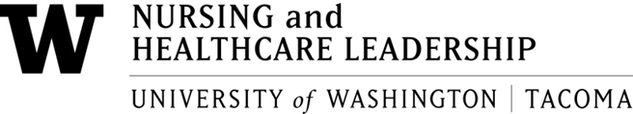

All faculty meeting
April 8, 2025
9-11am
Zoom meeting location: All Faculty Meeting zoom

- Welcome

- Approve minutes for March 2025

- Teaching faculty criteria for merit and promotion

  - Andrea Hill, PhD, 9 – 9:15 am
School of Social work and Criminal justice
Chair elect of Faculty assembly 2025 - 2026
    - Role of the teaching faculty of UWT
    - importance of merit review and promotion criteria that is clear
    - Issues and barriers for teaching faculty around criteria
    - Changes made to criteria based on those issues and barriers

  - Patsy Maloney, Phd taskforce on revision of the teaching criteria 9:15 – 9:30
    - Review of the proposed document (faculty code etc)

  - All faculty discussion of criteria 9:30 – 10:30

  - Next steps 10:30–10:45

- Committee appointments 10:45-11
  - Workload about committee work
  - Campus and SNCHL appointments or renewals/Meeting times for next year
  - Preview of service workload issues for faculty: 1. changing to 2 curriculum committees, 2. service expectations in campus wide committees, 3. compensation for high service loads

