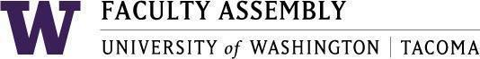

**Agenda**

**Faculty Affairs Committee Meeting**

January 13, 2025 / 12:30pm-1:20 p.m.

Zoom

1. **Recording Permissions/Consent** **[2 mins]**
2. **AI Discussion with Dr. Richard S. Lewis [50 mins]**

Join Zoom Meeting

<https://washington.zoom.us/j/98908537183>

Meeting ID: 989 0853 7183

Dial by your location

• +1 253 215 8782 US (Tacoma)

• +1 206 337 9723 US (Seattle)