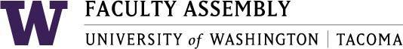

**Agenda**

**Faculty Affairs Committee Meeting**

June 7, 2018 12:30pm-2:00pm SCI 104

1. Consent Agenda & Approval of Minutes
   * *Meeting materials: May 10, 2018 Faculty Affairs Committee Minutes*
2. FAC 2018 Final Report
   * *Review Draft and Prepare Final Version*
3. Non-competitive Hiring Policy Draft
4. Next Year
5. Teaching Evaluation Policy Draft
6. Changes to UW Faculty Code
7. Adjourn

Tabled items:

Climate Survey

Parking

Childcare

Sound Transit